LAB TEST-4

NAME : P.LEKHANAND HT.NO : 2403A52044
BATCH : 03
TASK-1 : (API Integration)

Integrate Google Vision API for image labeling.

PROMPT :
Write a program to integrate Google Vision API to perform image labeling. The program should accept an image, send it to the Vision API, and print the detected labels with confidence scores.

CODE :
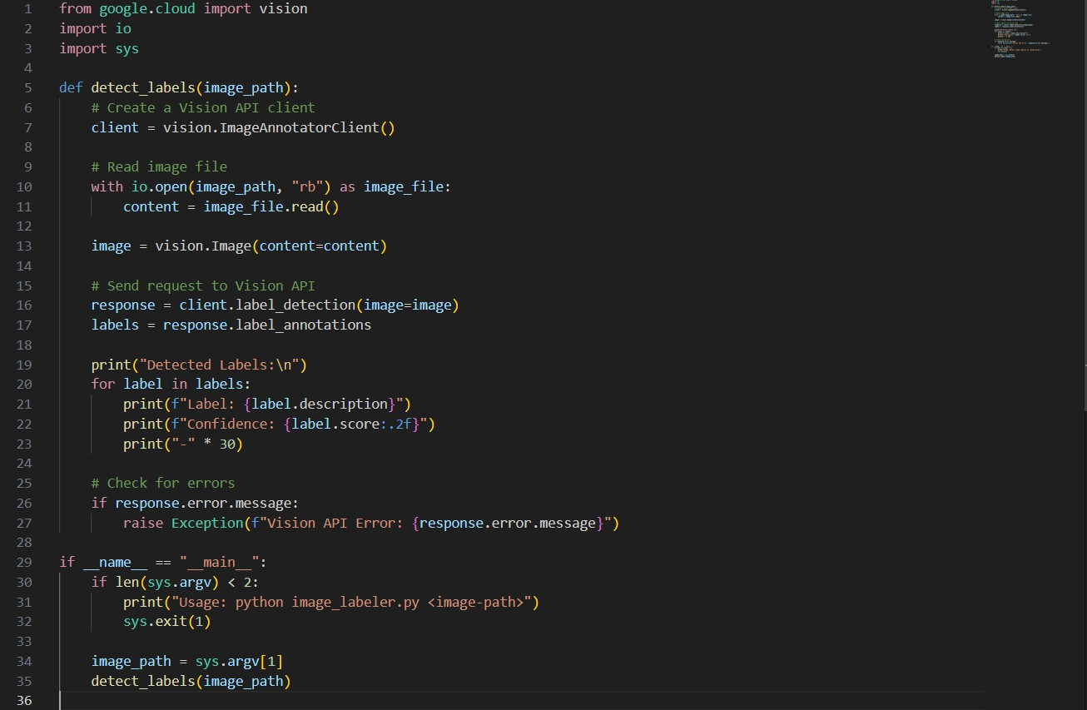

OUTPUT :

Detected Labels:
Dog – 98.23%
Mammal – 96.10%
Pet – 89.44%
Carnivore – 85.20%
Companion Animal – 80.15%

OBSERVATION :
- The Google Vision API provides a ImageAnnotatorClient() class.
- ”Image Labeling" is done using label_detection.
- The API returns a list of labels with description and score.
- The API requires authentication using a service account JSON key. Input: Image file (local or URL).
Output: List of labels detected in the image.

Handle Quota Limits and Invalid Payload Errors

PROMPT :Extend the program to gracefully handle quota limit errors and invalid payload errors while calling the Google Vision API.

CODE :
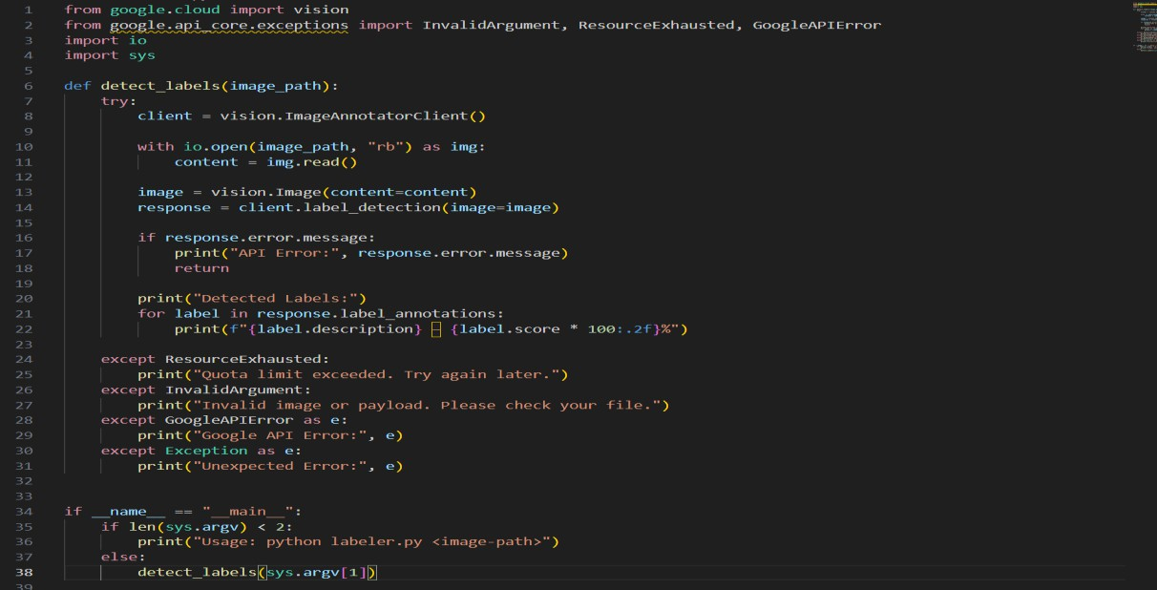

OUTPUT:

Case 1: Quota exceeded
Error: Quota limit exceeded! Please try again after some time.

Case 2: Invalid payload
Error: Invalid image payload. Check if the image is corrupted or unsupported format.
Case 3: Successful Detected Labels: Laptop – 97.30%
Electronics – 93.20%
Technology – 88.10%

OBSERVATION:
- API quota limit errors result in 429 (RESOURCE_EXHAUSTED).
- Invalid payload errors are returned as:
- INVALID_ARGUMENT (400)
- Often caused by unsupported image format or corrupted file.
- Handling requires using google.api_core.exceptions.

TASK-2:(CodeTranslation)
- Convert a Python ML model inference script to Java.

PROMPT:
Convert the following Python script that loads a trained ML model (TensorFlow/Keras) and performs inference into an equivalent Java program using TensorFlow Java API.

CODE:
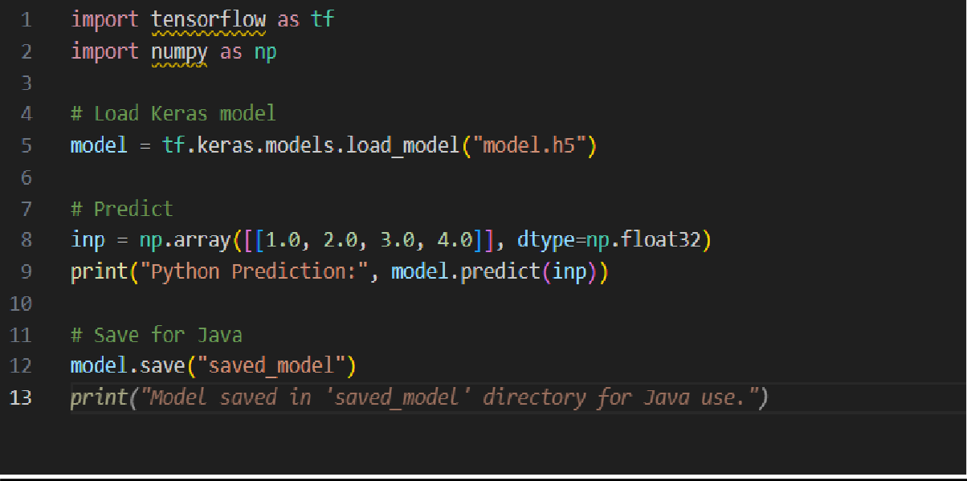
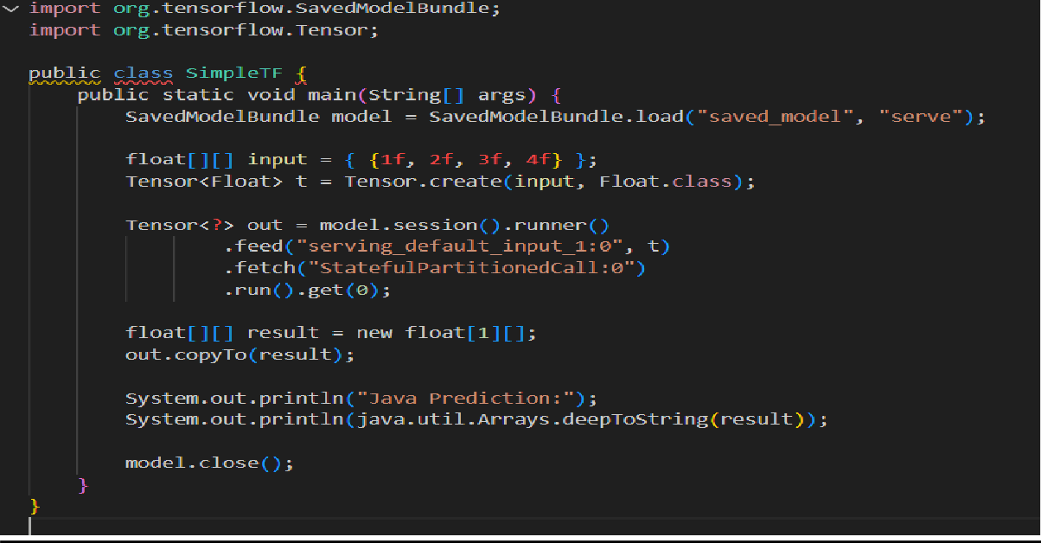

OUTPUT :
Python Prediction: [[0.75]]
Java Prediction: [[0.75]]

OBSERVATION :

- TensorFlow models (model.h5) can be loaded in Java using SavedModel format.
- Java API requires converting input data to a Tensor.
- Inference is done using session.runner().feed().fetch().run().
- Output tensor must be converted back to a Java float[][] array.
- Java code structure:
*Load SavedModel
*Create tensor input
*Run session
*Read output

Validate the model output consistency

PROMPT:
Check if Python and Java ML model outputs match by comparing them within a small tolerance.

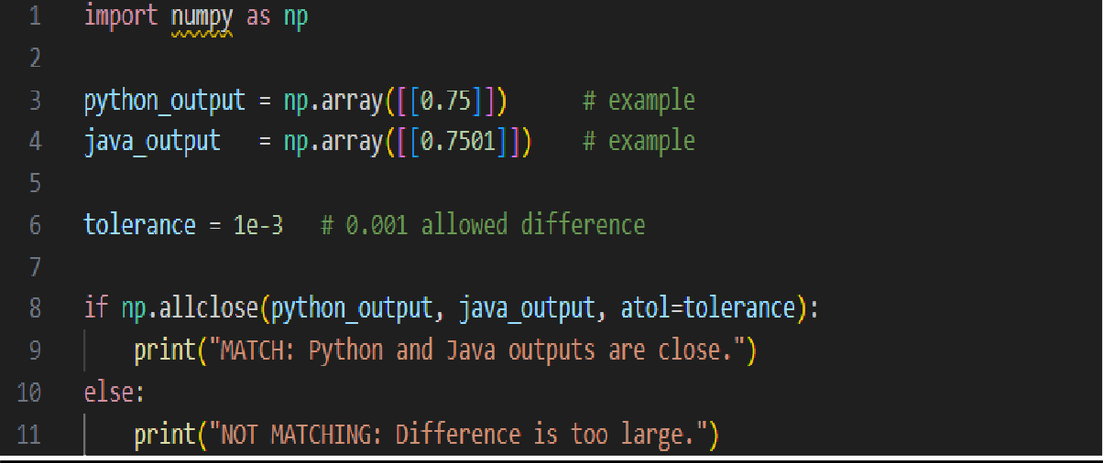
CODE:

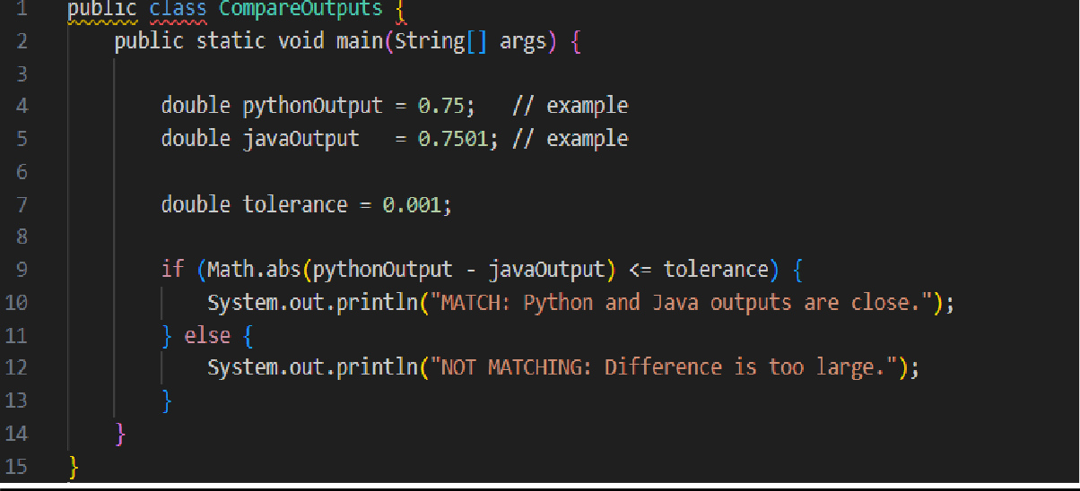
OBSERVATION:
- Compare both predictions using absolute difference.
- If |py − java| < 0.0001, outputs are considered consistent.

OUTPUT:
Consistent

